Quarterly Chapter Report for
Beaver State Chapter #108

What a fun quarter for our Chapter. Our annual picnic was held and we had great attendance. Our host, Howard, WB7OK, prepared a scrumptious lunch of BBQ hot dogs, hamburgers, and salmon burgers for the vegetarians. Everyone brought their favorite salad, dessert and/or side dish. Only one taker of the salmon burgers showed we all love our meat. The temperature soared into the high 90’s but that didn’t seem to diminish the exuberance and comradery of the day. It was a fun day.

We missed the report for last quarter so I’ll give a quick update. We had a wonderful visit to the Evergreen Aviation Museum in Monmouth, Oregon. Chapter member attendance was phenomenal. The EAM is home to Howard Hughes Spruce Goose, in case you forgot. There are numerous commercial and experimental aircraft on display from the Wright Brothers, to a Stealth aircraft (SR17), and the Space Museum has actual size mockups of the Apollo mission Lunar Landings and an actual Titan rocket. One could easily spend a couple of days touring the various exhibits.
Well, that is enough for now. See you next quarter.

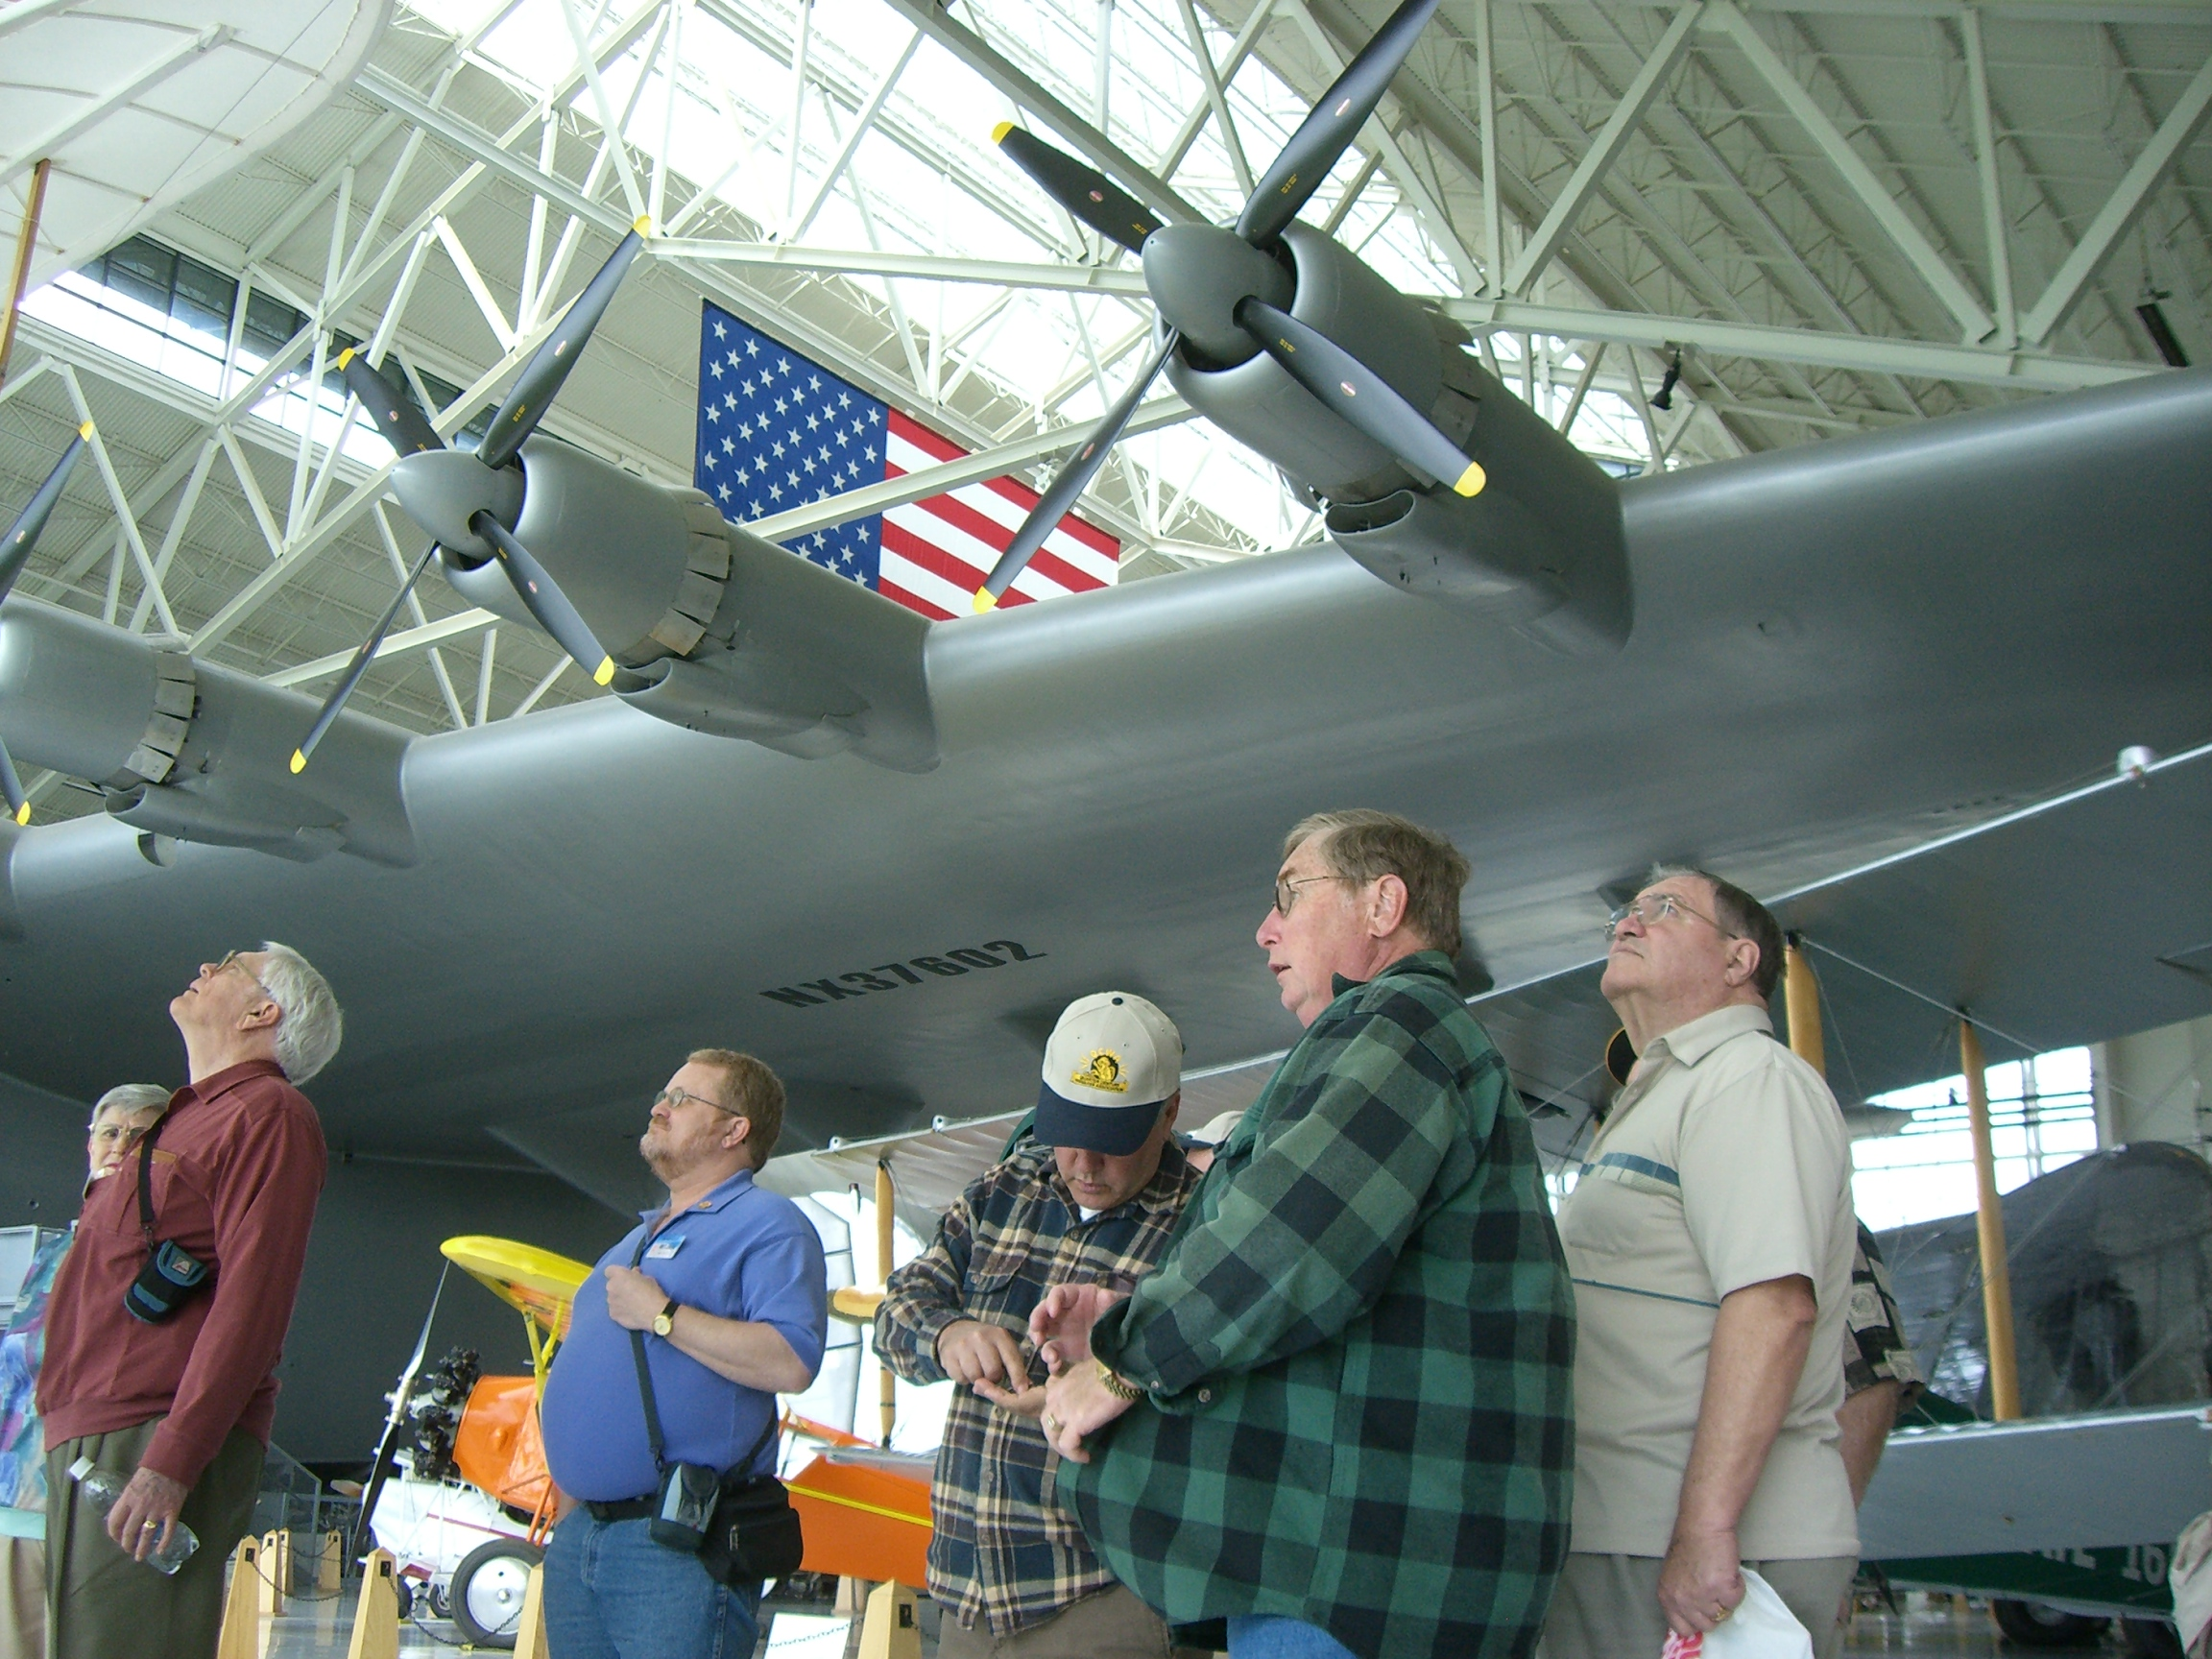
Figure 1. Evergreen Aviation Museum visit under the wing of the Spruce Goose. From left, Kay Robinson, Alan, W4LKE, ??, Howard, WB7OK, Gene, K6YIS, Dick Knight

Howard Honig, WB7OK
Secr/Treas
Beaver State Chapter 108

